1. **BPM/BRM Development and Source code Management with KIE-WB**

**About KIE-WB –**

The workbench is the web-based application that combines multiple web-based tools into one configurable solution.

It supports the following:

* A repository service to store your business processes and related artifacts, using a Git repository, which supports versioning, remote accessing (as a file system), and using REST services.
* A web-based user interface to manage your business processes, targeted towards business users; it also supports the visualization (and editing) of your artifacts (the web-based editors like designer, data and form modeler are integrated here), but also categorization, build and deployment, etc.
* Collaboration features to have multiple actors (for example business users and developers) work together on the same project.
* Workbench application covers complete life cycle of BPM projects starting at authoring phase, going through implementation, execution and monitoring.

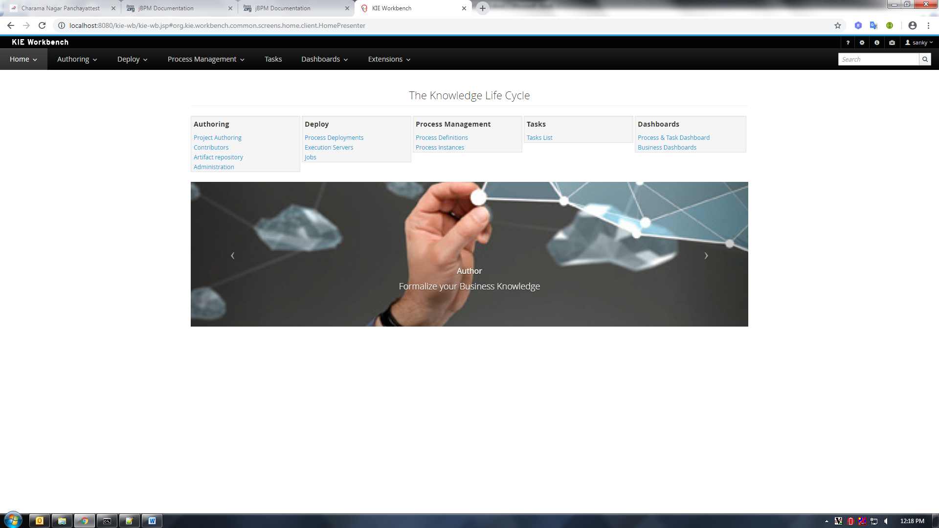

**KIE-WB Usage guide –**

*Please Refer -* [*https://docs.jboss.org/jbpm/release/6.5.0.Final/jbpm-docs/html_single/#wb.Authoring*](https://docs.jboss.org/jbpm/release/6.5.0.Final/jbpm-docs/html_single/#wb.Authoring)

**GIT Repository –**

* To create any project in kie-wb it is required to create repository first.
* Kie-wb allows us to create new repository using administration tools.
* This repository will be GIT repository.
* All files in side this repository will be managed by GIT protocol with specific revision ID.
* We are using Multi-project Repository which will allows us to manage all BPM or BRM related project at one place.

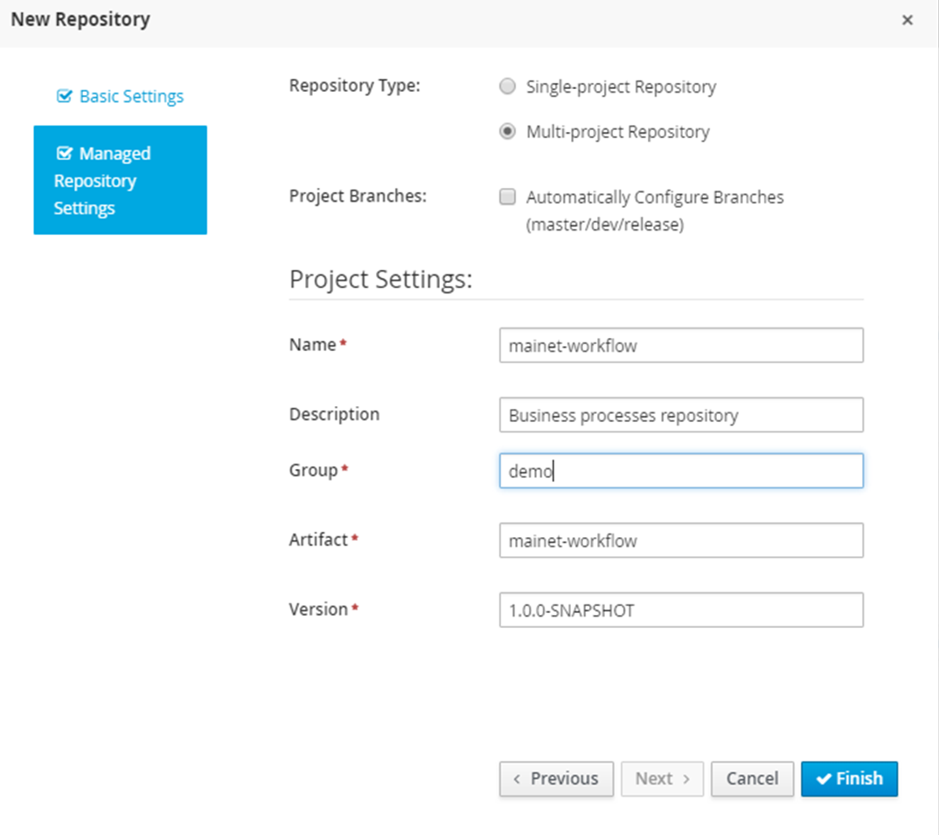

* After successful creation of repository in kie-wb we will get **.git** file with repository name in side “JBOSS_HOME/bin/.niogit” directory.
* This is standard GIT repository which can be clone to any other kie-wb environment.( Explained in “JBPM_CLONE_&_DEPLOY_V1.docx”)
* Business processes repository is “**mainet-workflow.git**”
* Business rules repository is “**mainet-brms.git**”

**Projects Versioning –**

* Any project created in side any GIT repository using kie-wb will standard maven projects.
* Maven project will have its own dedicated group Id, artifact Id, and version.
* When we deploy any project in side kie-wb it will be identified by its deployment Id.
* Deployment id is combination of group Id, artifact Id, and version (Ex. com.abm.mainet:CheckList:1.0)
* When we deploy any new version of any project in kie-be we change the version of that maven project only, so it will be identified with new deployment Id.
* As off now, we are not minting BRM project by maven versions.
* BPM projects will be managed with maven version given in ordered sequences and snapshot or release identifiers for internal and production environment respectively.
* All BPM processes project are dependent on common project created to maintain all java types. To keep it easy to maintain we are following same version of common project for all dependent project inside kie-wb.

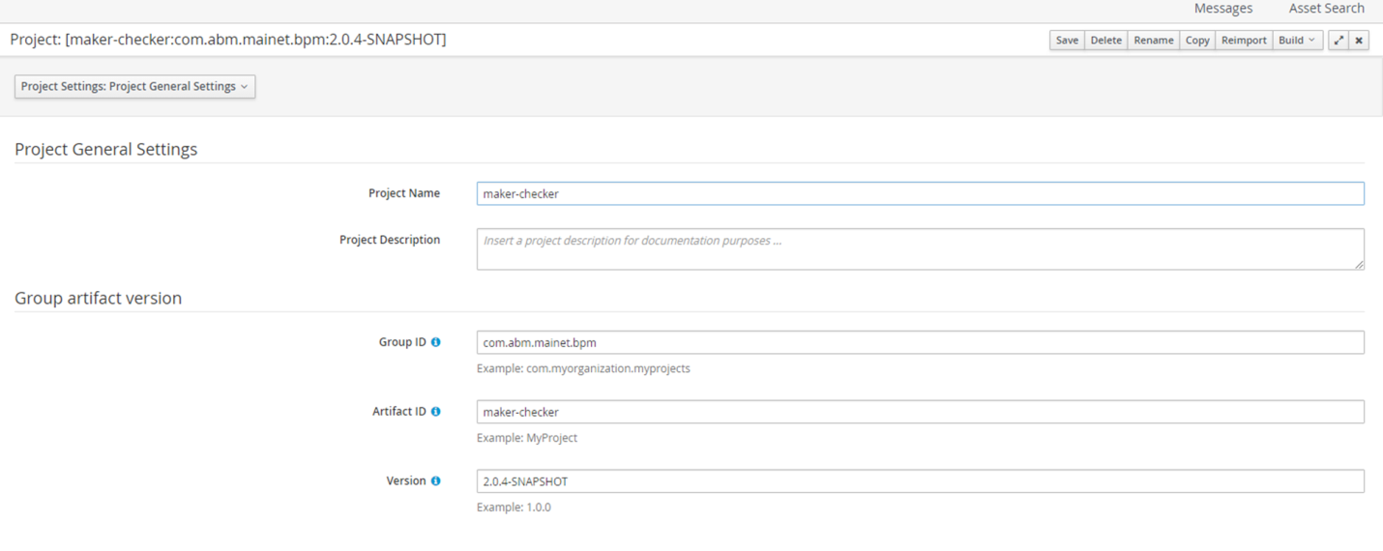

* Project maven dependencies

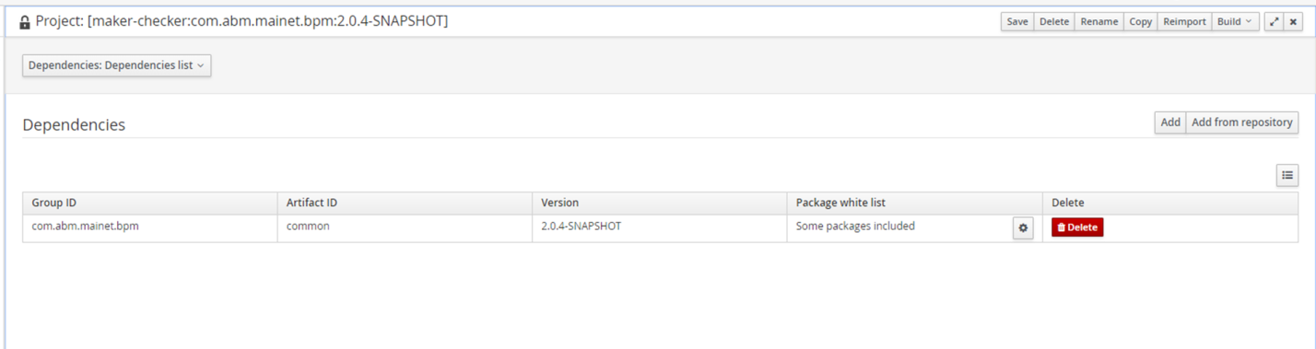

**Kie-wb project export –**

* We can either download whole repository or single project only from kie-wb.
* When we download source using this feature of kie-wb, it will download all resources simple file system format in single .zip file. This means that we are downloading pure source code only instead of whole git structure.
* This source code can be committed in SVN as similar as what we are following for MainetService and MainetBpmService or any other application

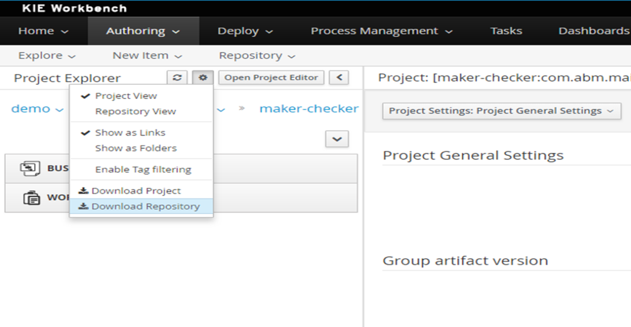

**Kie-wb project imports –**

* To import whole project in kie-wb we have clone GIT repository in which that project exist.
* Download file cannot be clone into Kie-wb because it’s not containing any information related to GIT structure.
* To import repository of any environment to other we need to clone ‘.git’ file retrieved from .niogit directory of server.

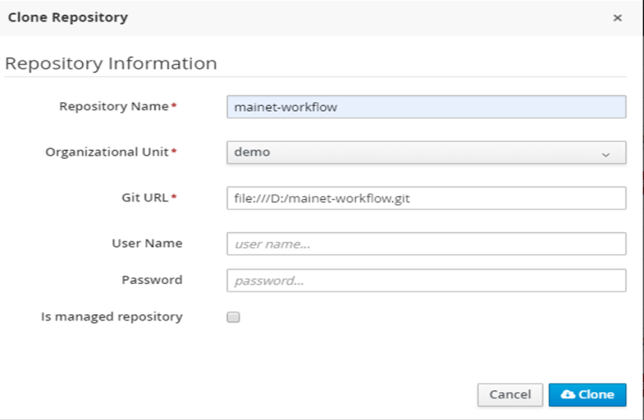

1. **Versioning in SVN**

Processes SVN Paths - <https://192.168.100.7/svn/ABM_SAAS_Product/branches/projects/suda/documents/releases/release_documents/BPMS_Process>

Rules SVN Paths –

<https://192.168.100.7/svn/ABM_SAAS_Product/branches/projects/suda/documents/releases/release_documents/BRMS_Rules>

* As explained earlier, we need .git files to imports whole repository in kie-wb, for the reason we are managing whole .git repository in SVN.
* SVN path given above contains separate directories for each environment of deployment process. (198, 243, 246, Production)
* Each environment directory will contain multiple directories named with actual maven version of ‘.git’ file.
* Latest ‘.git’ file will be committed in 198/<versioned directory> from local development file system to use in common development environment (198), similarly tested or final ‘.git’ files will be committed in other folders to follow build and deployment process.
* This ‘.git’ file committed here at SVN will be used to clone in other environments. (Explained in “JBPM_CLONE_&_DEPLOY_V1.docx”)

